The New Frontier of Operational Resilience
Generative AI (GenAI) is transforming how financial institutions operate, from automating client communication to accelerating risk analysis. Yet behind this efficiency lies a subtle and growing vulnerability: the erosion of resilience.
Traditional resilience was measured in seconds of downtime. Systems were considered healthy if infrastructure stayed up and recovery times stayed within tolerance. But in the age of GenAI, availability no longer equals reliability. A model can be online and producing outputs — yet those outputs may have drifted, degraded, or deviated from expected logic. In other words, resilience now depends not only on whether a service is running, but on whether its decisions remain right.
This shift marks a turning point for banks. Operational continuity and model integrity are converging. As institutions embed AI into critical services, they must protect both the infrastructure and the intelligence that drives it.

Why AI Resilience ≠ System Uptime
AI systems introduce new failure modes that traditional continuity plans were never built to handle.
- Non-determinism: The same input can yield different outputs, making testing and regression analysis less predictable.
- External dependencies: Model performance often depends on third-party APIs, embedding providers, or orchestration layers outside direct control.
- Model drift: Over time, models learn, unlearn, or misalign with their original purpose — silently degrading quality.
- Knowledge erosion: As AI automates tasks, human expertise can fade, leaving organizations less capable of manual recovery if automation fails.
In short, a system can be “up” while business integrity quietly erodes. This is the resilience gap of the AI era — and it’s widening faster than most institutions realize.
At the same time, regulatory guidance is still evolving. Supervisory statements such as the Federal Reserve’s SR 11-7 on model risk, the Basel Committee’s 2023 Principles for AI and Machine Learning, the EU’s Digital Operational Resilience Act (DORA), and the NIST AI Risk Management Framework all emphasize governance and testing. Yet none fully address the dynamic behavior of large-scale GenAI systems. Banks cannot wait for regulators to close the gap; they must act pre-emptively.

Understanding Model Drift — The Hidden Continuity Threat
Drift is the silent risk of the AI era. It occurs when a model’s behavior changes in ways that reduce its accuracy, reliability, or fairness.
- Data drift happens when the nature of incoming data shifts — for example, new customer behaviors or unseen market patterns.
- Concept drift arises when the relationships between variables evolve — such as new fraud tactics or macroeconomic conditions.
- Process drift emerges when prompts, templates, or automation scripts evolve outside of formal change control.
In capital markets and risk management, even small drift events can distort decision outputs or reporting accuracy. The risk is not of outage, but of silent downgrade.
“In the past, outages stopped operations. Today, drift can mislead them.”
That distinction is why forward-looking banks are extending operational resilience frameworks beyond infrastructure to encompass model integrity, explainability, and governance.
7 Enhancement Levers

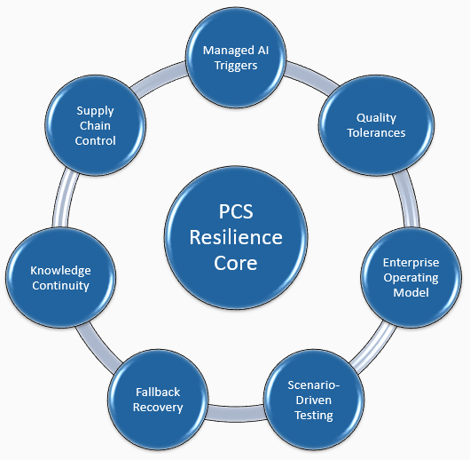
From Availability to Integrity: A New Resilience Paradigm
BIP’s perspective is simple: in the AI era, resilience must equal continuity of quality. To achieve that, banks should build on their existing Prioritized Critical Services (PCS) frameworks and evolve them into AI-aware resilience systems.
Drawing on our work with global financial institutions, BIP has developed a Tiered PCS Framework with Seven Enhancement Levers to operationalize resilience for GenAI and machine-learning systems:
- Managed AI Triggers – Define criteria for when AI systems enter resilience governance. Apply these triggers before deployment to ensure oversight from day one.
- Quality-Based Impact Tolerances – Extend metrics beyond uptime to include output accuracy, factuality, and decision reliability.
- Enterprise Operating Model – Establish a clear RASCI defining who owns drift detection, fallback decisions, and regulatory communication.
- Scenario-Driven Testing – Conduct periodic “AI Resilience Exercises” simulating provider outages, drift spikes, and adversarial prompts.
- Fallback & Recovery Patterns – Standardize transitions from Full AI → Guardrailed AI → Template + Human Review → Manual SOP.
- Staff & Knowledge Continuity – Preserve institutional knowledge through rotations, manual-mode rehearsals, and cross-training.
- Third-Party & Supply-Chain Controls – Map AI provider dependencies, enforce version-change SLAs, and maintain last-known-good model archives.
This seven-lever model helps banks evolve from static continuity planning to dynamic assurance — a system of continuous validation that keeps pace with model behavior.


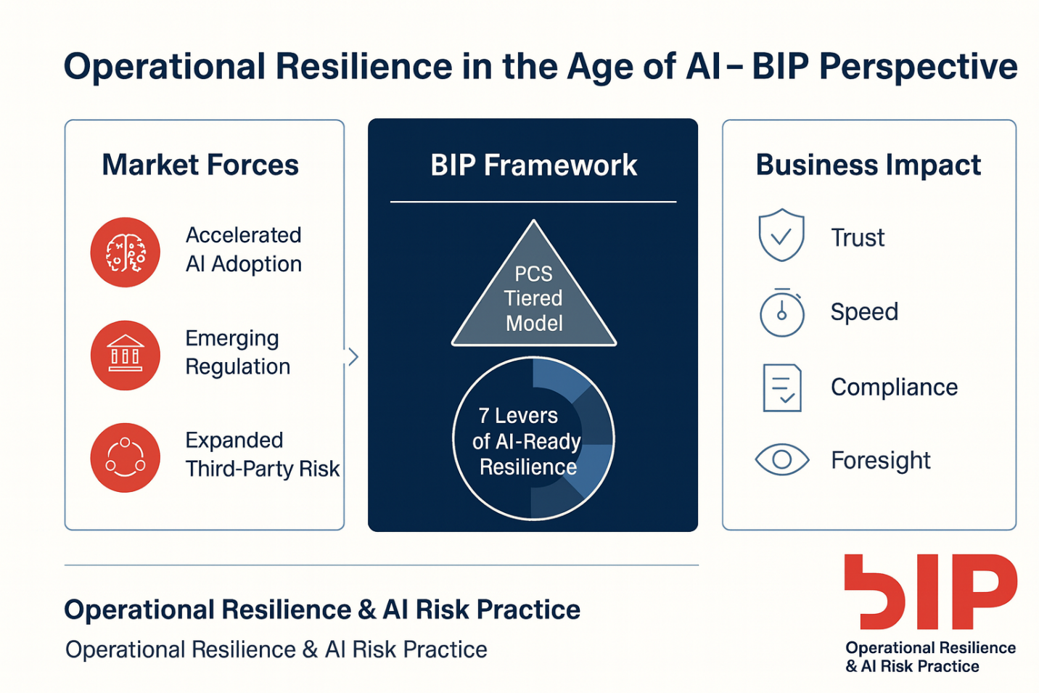

A Practical Blueprint: The 30–60 Day Collaborative Roadmap
While each institution’s timeline will vary, a short, structured initiative can provide tangible progress. BIP recommends a 30–60 Day Collaborative Roadmap, refined through a joint scoping session between Operational Resilience, AI Governance, and Model Risk teams.
- Phase 1 — Discovery (0–15 Days):
Map AI use across PCS, identify critical dependencies, and define preliminary drift metrics. Establish a baseline “AI-in-PCS inventory.”
- Phase 2 — Pilot Design (16–30 Days):
Test prototype controls, run tabletop simulations, and evaluate fallback readiness for one or two Tier-1 services.
- Phase 3 — Integration (31–60 Days):
Embed validated controls into governance templates, escalation protocols, and risk dashboards. Deliver implementation roadmap aligned with 2026 planning cycle.
This approach keeps momentum high, focuses effort where value is greatest, and delivers early proof points that resonate with regulators and boards alike.

From Reactive Recovery to Continuous Assurance
Resilience programs in most banks still revolve around recovery — restoring services after failure. But AI systems demand a shift toward continuous assurance — an active, forward-looking capability that monitors quality, detects deviation, and triggers intervention before business impact occurs.
“As AI becomes integral to every decision chain, resilience will no longer be a recovery exercise; it will be a living control function.”
Continuous assurance involves three capabilities:
- Automated monitoring – real-time data and model drift alerts.
- Tiered human oversight – defined thresholds for manual review.
- Adaptive testing – periodic recalibration to reflect business and market change.
BIP’s work with leading institutions shows that integrating these capabilities reduces AI-related operational incidents by up to 40% within the first year — while significantly improving regulator confidence in governance maturity.

The Regulatory Horizon
The regulatory environment is catching up. Supervisors across the U.S., U.K., and Europe are emphasizing the need for explainability, human accountability, and model life-cycle governance.
- SR 11-7 is being reinterpreted to encompass machine learning validation.
- DORA mandates ICT risk testing and third-party oversight — extending naturally to AI vendors.
- BCBS Principles for AI emphasize transparency, auditability, and data lineage.
- NIST AI RMF provides the structure for trustworthy AI practices.
While full alignment across jurisdictions is still evolving, banks that operationalize resilience now will be best prepared for convergence in 2026–2027.

Leading with Foresight
For today’s global financial institutions, the question is no longer whether AI belongs in critical operations — but how to make those operations safe, stable, and auditable.
BIP’s integrated approach — combining operational resilience, model risk management, and governance — enables banks to move from experimentation to assurance. The goal is not to slow innovation, but to make it sustainable.
By embedding resilience at the design stage, banks can unlock the advantages of AI while meeting their obligations to customers, regulators, and shareholders.
“True resilience is not about surviving disruption. It’s about building systems that learn, adapt, and improve through it.”

About BIP
BIP is a global consulting firm specializing in digital transformation and risk innovation. Our Operational Resilience & AI Risk Practice helps leading financial institutions design governance, controls, and testing frameworks that keep pace with the evolution of intelligent systems.

